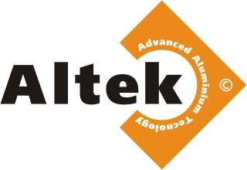

Percentage of contamination of supplied raw materials
GROUP 1-1. El./tech. (briquette and bulk)
- Wires - briquette 0.3% in the absence of extraneous metal inclusions in the form of studs, bolts, self-tapping screws, sheds and inserts, copper objects including copper wire, etc. (contamination in fact), bulk (from 0.5% to 2%), covered in oil (from 0.5%)
- Barrel (contamination in fact) (covered in paint, resin, etc. from 0.5%)
- Flask (from 40 l) without inclusions (0.3%)
- A-5 briquette, sheet (contamination in fact)
- Busbar (paint from 0.5%).
- Spike strips - (3-16%.)
- Braid - delivery as agreed
- Offset (16%)
- Other raw materials suitable for chemical analysis (contamination in fact).

GROUP 1-2. Food grade.

- Clean dishes - briquette 1% in the absence of extraneous metal inclusions in the form of studs, bolts, self-tapping screws, sheds and inserts, copper objects, including copper wire, etc. (contamination in fact), aluminum, clogged with plastic waste, wood, metal parts, etc. (from 1%).
- Teflon is not acceptted.

GROUP 2-2. AD (briquette bulk)

- Clean - 0.1% briquette in the absence of extraneous metal inclusions in the form of studs, bolts, self-tapping screws, canopies and inserts, copper objects, including copper wire, etc. (contamination in fact), with metal inclusions (from 1%)
- Thermal insert (do not accept), wired film (from 1%) - as agreed.
- With insulation - do not accept.
- Painted (from 1.5%)
- Dimension AD bulk up to 1.5m (over it - our processing of 3.5%)
- Other raw materials suitable for chemical analysis (contamination in fact).
- In big bags, homogeneous raw materials (less than 0.5 meters from 1%)
- Formwork - 1-10% (over - return)
- Bulk - do not accept
- Busbar (from 0.5%)

GROUP 3. Delivery as agreed

1. AMr (up to 1%)
2. AMc (up to 1%)
Raw material with a high-rate contamination, oversized to be returned
In case of return - storage no more than 14 days, the raw materials go over
into the ownership of the enterprise.

